# **CHAPTER 5: SOFTWARE TESTING DOCUMENT**

## **5.1 Introduction**

### 5.1.1 Purpose

The test plan contains a detailed understanding of the workflow and functions of the system and documents how each of those will be tested in order to find out if the system works according to its design, to find bugs, and to determine its actual limitations. Using the contents of this chapter, developers and testers can work together to ensure that the system is thoroughly tested and functions as intended. It contains the following sections:

* Test strategy
* Test plan
* Test approach
* Defect log
* Test report

## **5.2 Test strategy**

### 5.2.1 Objective and scope

The objective of testing is to satisfy all the requirement of the business use cases. The scope of this test will be limited to testing FIM web application. The quality goal is 100% test cases are executed and 98% passed.

### 5.2.2 Testing tools and environment

#### 5.2.2.1 Testing tools

The following tools are used for testing:

**Google Chrome:** Use to view the web page, bug logging page, …



*Figure 5-1: Google Chrome* version *78.0.3904.108*

**Microsoft Excel:** Use to manage test cases



*Figure 5-2: Microsoft Excel 2016*

**Trello:** User to manage bug



*Figure 5-3: Trello*

**MSTest:** Use to perform unit tests

**SmartPhone:** Use to view the web page, bug logging page, etc..

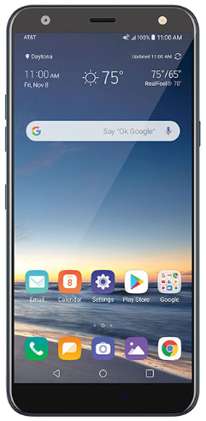

*Figure 5-4: Smartphone*

#### 5.2.2.2 Testing environment

|  |  |  |
| --- | --- | --- |
| **Type of testing** | **Software** | **Hardware** |
| Unit test | MSTest | Laptop Lenovo Thinkpad:  o Windows 10 Pro  o Intel core i7 2.6GHz  o 8GB Memory  o Screen resolution: 1920 x 1080 |
| Integration test | -Google chrome version 78.0.3904.108  - Microsoft Office Excel 2016.  - Microsoft Office Word 2016 | Laptop Lenovo Thinkpad:  o Windows 10 Pro  o Intel core i7 2.6GHz  o 8GB Memory  o Screen resolution: 1920 x 1080 |
| System test | -Google chrome  version 78.0.3904.108  - Microsoft Office Excel 2016.  - Microsoft Office Word 2016 | Laptop Lenovo Thinkpad:  o Windows 10 Pro  o Intel core i7 2.6GHz  o 8GB Memory  o Screen resolution: 1920 x 1080 |

### 5.2.3 Resources and responsibilities

|  |  |  |
| --- | --- | --- |
| No | Resources | Responsibilities |
| 1 | Project manager | * Responsible for project schedules and overall success of the project. |
| 2 | Test leader | * Manage overall of the software quality. * Define test strategy. * Define test plan, test approach. * Create and review test case, defect log. |
| 3 | Tester | * Understand the requirements of the project. * Implement integration test following requirement. * Create test cases. * Execute test. * Log bug. |
| 4 | Developer | * Create unit test * Fix bug |

### 5.2.4 Acceptance criteria

|  |  |  |
| --- | --- | --- |
| No | Acceptance criteria | Note |
| 1 | 100% test cases are executed |  |
| 2 | 98% test cases are passed |  |
| 3 | 95% of medium severity defects have been closed |  |
| 4 | 100% of high severity defects have been closed |  |

### 5.2.5 Risk List

|  |  |  |  |  |
| --- | --- | --- | --- | --- |
| No | Condition | Mitigation | Contingency | Doer |
| 1 | The hardware maybe corrupted when testing | Change hardware | Re-plan schedule | TungBC |

### 5.2.6 Test Process

The test process is following the FPT-Software process.

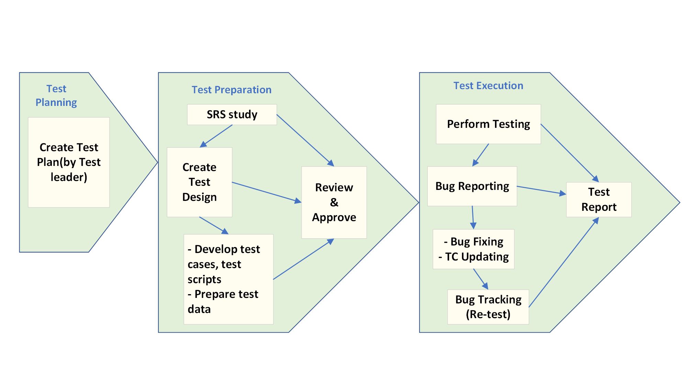

*Figure 5-1.Test process*

**Description:**

1. **Test plan:** Test leader takes responsible to create a test plan.
2. **Test preparation:** Testing team study the SRS document, create test design for each stage.
3. **Test execution:** Tester and developer perform the test following the plan. The bug is logged by tester and developer is assigned to fix the code in order to fix the bugs.

## **5.3 Test Plan**

### 5.3.1 Test Model

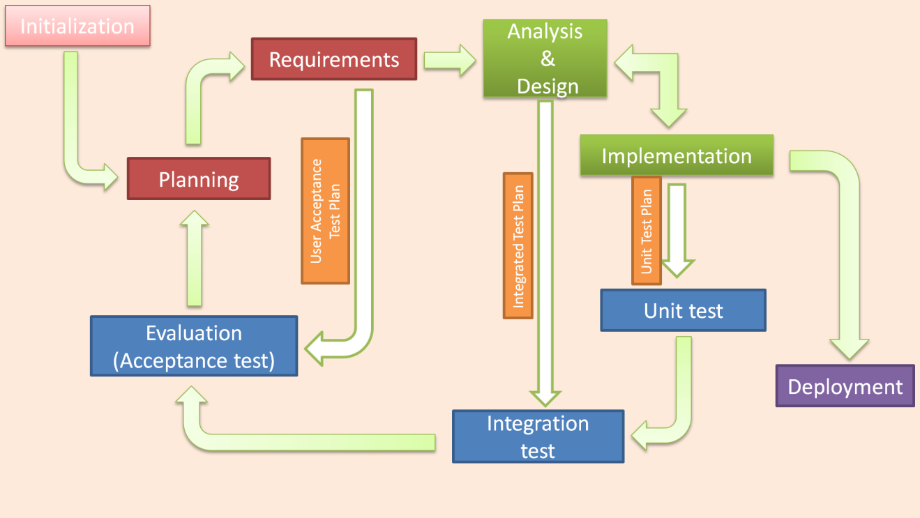

*Figure 5‑2.Iterative testing model*

### 5.3.2 Stage of testing

|  |  |  |  |
| --- | --- | --- | --- |
| No | Testing level | Description | Implementation |
| 1 | Unit test | * **Unit test is performed by developers.** * **All the test cases are NOT documented.** | Development team:   1. Bùi Trug Kiên 2. Bùi Công Tùng 3. Đỗ Đình Đức 4. Trần Quang Thọ |
| 2 | Integration test | * **Integration test is performed by testers.** * **Material is “integration_test_case_v2.0.xls”.** | Tester team:   1. Trần Quang Thọ 2. Bùi Công Tùng 3. Nguyễn Hữu Hóa 4. Đỗ Đình Đức |
| 3 | System test | * **System test is performed by testers.** * **Material is “System_test_case.xls”.** | Tester team:   1. Trần Quang Thọ 2. Bùi Công Tùng 3. Nguyễn Hữu Hóa 4. Đỗ Đình Đức |
| 4 | Acceptance test | Acceptance test is performed by BA.  Material “User requirement”, “Check list”. | BA team:   1. Bùi Trung Kiên |
| No | Testing level | Description | Implementation |
| 1 | Unit test | * **Unit test is performed by developers.** * **All the test cases are NOT documented.** | Development team:   1. Bùi Trung Kiên 2. Bùi Công Tùng 3. Đỗ Đình Đức 4. Trần Quang Thọ |
| 2 | Integration test | * **Integration test is performed by testers.** * **Material is “integration_test_case_v2.0.xls”.** | Tester team:   1. Trần Quang Thọ 2. Bùi Công Tùng 3. Nguyễn Hữu Hóa 4. Đỗ Đình Đức |
| 3 | System test | * **System test is performed by testers.** * **Material is “System_test_case.xls”.** | Tester team:   1. Trần Quang Thọ 2. Bùi Công Tùng 3. Nguyễn Hữu Hóa 4. Đỗ Đình Đức |
| 4 | Acceptance test | Acceptance test is performed by BA.  Material “User requirement”, “Check list”. | BA team:   1. Bùi Trung Kiên |

### 5.3.3 Function to be tested

No comment

### 5.3.4 Function not to be tested

No comment

### 5.3.5 Type of testing

The following type of testing is used in this project are:

|  |  |  |
| --- | --- | --- |
| No | Type of test | Description |
| 1 | Automation unit test | * Testing on code level to identify bugs in functions. |
| 2 | GUI test | * GUI test is used to test the user interface of the software. It will be performed fully on all screens. The target is to cover the verification of mocks defined before. It also includes fields:  1. Check if error messages are displayed correctly. 2. Check if Font is readable. 3. Check the screen solution |
| 3 | Functional test | * Functional test is used to test for each logical path of use case. |
| 4 | Acceptance test | * Passing all the use case without critical errors. |

The table below are the stages in which test are executed:

|  |  |  |  |  |
| --- | --- | --- | --- | --- |
| Type of test | Stage of test | | | |
| Unit test | Integration test | System test | Acceptance test |
| Automation unit test | √ |  |  |  |
| GUI test |  | √ | √ | √ |
| Functional test |  | √ | √ | √ |
| Acceptance test |  |  |  | √ |

### 5.3.6 Test Schedule

|  |  |  |  |
| --- | --- | --- | --- |
| Task | | Start date | End date |
| Iterator 1 | Create test plan | 09/15/2019 | 16/10/2019 |
| Create and execute unit test | 09/18/2019 | 23/10/2019 |
| Create and execute integration test | 09/18/2019 | 22/10/2019 |
| Create and execute system test | 09/25/2019 | 26/10/2019 |
| Create and execute acceptance test | 09/28/2019 | 28/10/2019 |
| Iterator 2 | Create test plan | 09/30/2019 | 02/11/2019 |
| Create and execute unit test | 11/02/2019 | 07/11/2019 |
| Create and execute integration test | 11/10/2019 | 17/11/2019 |
| Create and execute system test | 11/18/2019 | 20/11/2019 |
| Create and execute acceptance test | 11/22/2019 | 24/11/2019 |

### 5.3.7 Deliverables

|  |  |  |  |
| --- | --- | --- | --- |
| No | Deliverables | Responsibilities | Delivered date |
| 1 | Test plan | Trần Quang Thọ | 02/11/2019 |
| 2 | Unit test | Bùi Công Tùng, Trần Quang Thọ, Nguyễn Hữu Hóa | 07/11/2019 |
| 3 | Integration test | Bùi Công Tùng, Nguyễn Hữu Hóa, Bùi Trung Kiên | 17/11/2019 |
| 4 | System test | Đỗ Đình Đức | 20/11/2019 |
| 5 | Acceptance test | Bùi Trung Kiên | 24/11/2019 |
| 6 | Defect logs | Đỗ Đình Đức | 09/12/2019 |
| 7 | Final test summary report | Trần Quang Thọ | 11/12/2019 |

## **5.4 Test Approach**

### 5.4.1 Unit Test

No Comment

#### 5.4.1.1 Implement junit library

No Comment

#### 5.4.1.2 Create Test Case and Test Method

No Comment

#### 5.4.1.3 Execute Unit Test

No Comment

#### 5.4.1.4 Test Result

No Comment

### 5.4.2 Integration Test

### 5.4.3 Acceptance Test

The purpose of this test is to having end-user perception while testing and understand business need for each requirement and test accordingly. But our project will use the checklist as a substitute for acceptance testing.

The content of the checklist is shown in the table below:

|  |  |  |
| --- | --- | --- |
| ID | CheckLists | Status |
| **General** | | |
| AT-001 | All mandatory fields are validated. | Done |
| AT-002 | All error messages are displayed in red color. | Done |
| AT-003 | Delete functionality for any record on a page are asked for confirmation. | Done |
| AT-004 | Text on all pages for spelling and grammatical errors. | Done |
| AT-005 | Application crash or unavailable pages are redirected to an error page. | Done |
| **GUI & USABILITY** | | |
| AT-006 | The screen is well organized and easy to use. | Done |
| AT-007 | All fields on page (e.g. text box, radio options, dropdown lists) should be aligned properly. | Done |
| AT-008 | The most important fields are located where they are easy to see. | Done |
| AT-009 | Information is presented in the order that the user needs it. | Done |
| AT-010 | The screen designed to fit the requirements for international use. | Done |
| AT-011 | The static text is clear, concise, and meaningful. | Done |
| AT-012 | System display notification message when meeting trouble, error. | Done |
| **DATABASE** | | |
| AT-013 | Correct data is getting saved in the database upon a successful page submit. | Done |
| AT-014 | Values columns are not accepting null values. | Done |
| AT-015 | Data should be stored in single or multiple tables based on design. | Done |
| AT-016 | Database fields are designed with correct data type and data length. | Done |
| **SECURITY** | | |
| AT-017 | Test cookie allowed (disabled or allowed to be edited) | Done |
| AT-018 | Check login, logout functionality. | Done |

### 5.4.4 Defect Log

FIM project using Trello to manage bug . Processes are:

- During the testing process, when a bug is found, testers access trello.com to log in with the “Bug” label (highlight color).

- The bug must be described as detailed as possible with screenshots.

- The issue is then assigned to a developer, who is in charge of developing that module.

- Assigned developer checks out the issue in trello.com, move that card to “In Progress” List and fixes it. Once the bug is resolved, the assigned developer drag that card to “Fixed” List

- The tester then verifies if the bug in “Fixed” List. If the bug is fixed, drag that card to “Done” List. If the bug is not fixed, tester move card to “Open” List and assign it to the developer again.

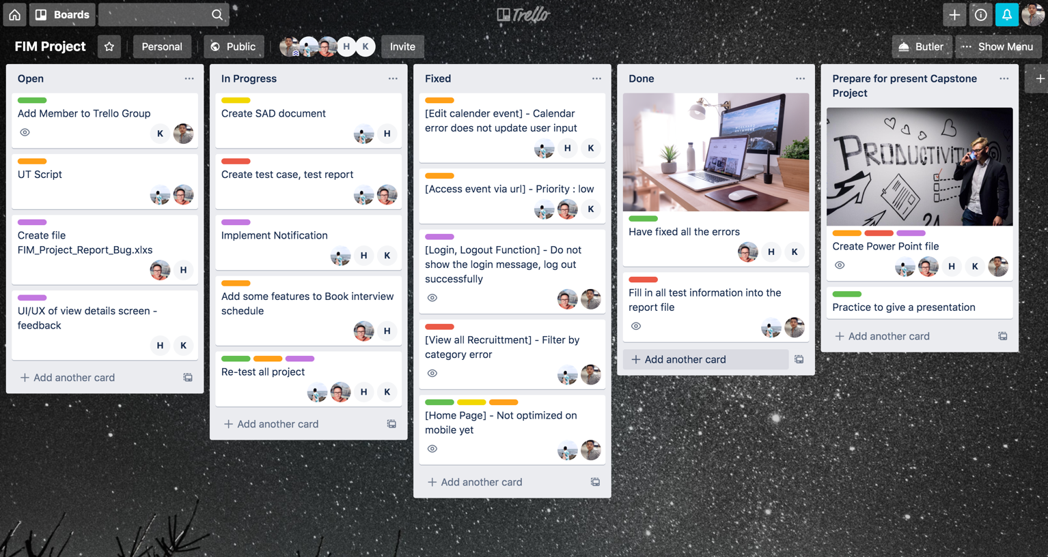

*Figure 10 : Defect log management tool.*

## **5.5 Test Report**

### 5.5.1 Unit Test Report

No Comment

### 5.5.2 Integration Test Report

No Comment